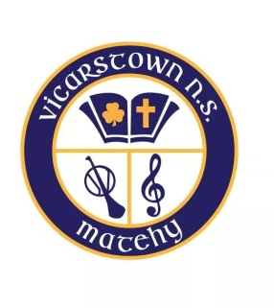
Scoil Náisiúnta Baile an Bhiocáire Tel: 021-7332179 roll No. 06342L
Book List Senior Infants – 2021-2022
English
Wonderland- CJ Fallon
Elle Goes to the Airport
The Wrong Car
Globby Helps Out
The Beach House

Activity Books
Skills Book C
Skills Book D

Writing
New Wave Hand Writing – Senior Infants (Prime-Ed)

Phonics
Sounds Like Phonics Activity Book B – Senior Infants (CJ Fallon)

Irish
Bua na Cainte B- Edco

Maths
Busy At Maths – CJ Fallons – Senior Infants

Religion
Grow in Love – Senior Infants –Primary 2

SPHE
Mindful Matters (B)

Copy Books
1 x 15A project copy (Ormond 40 page)
3 X 80 page Copies

2 X B2 (headline) Copies (Ormond)

2 X A4 Button Folder
1 x tube of Pritt stick
Pencil Case with rubber, sharpener and crayons/twistables

*Correct pencils will be provided by the school in September*

All books to be clearly marked on the FRONT cover.
Please label tracksuit, uniform, coats and all child’s belongings

